## **Create a Development Environment for Power BI Embedding**

**Setup Time**: 10 minutes

**Overview**: As you move through this setup guide, you will create a new Azure AD tenant with Office 365 E5 trial licenses and you will configure this Azure AD tenant to serve as a development environment for building and testing solutions that use Power BI embedding. After creating the tenant, you will be able to log in with a new user account configured to run as the tenant Global administrator and as a Power BI Service administrator. That means you will have full control to configure tenant-level settings for the Power BI Service.

You will also be able to create additional user accounts for testing purposes. Remember that any Azure AD user account with an Office 365 E5 subscription is automatically assigned a Power BI Pro license as well. The tenant you create can be used as a development environment write and test PowerShell scripts. It can also be used to develop and test custom applications that implement Power BI embedding using both the Power BI Service API and the Power BI JavaScript API.

1. Navigate to the Office 365 trial sign up web page.
   1. Launch the Chrome browser.
   2. Copy and paste the following URL into the address bar of the incognito window to navigate to the signup page.

<https://go.microsoft.com/fwlink/p/?LinkID=698279&culture=en-US&country=US>

* 1. You should now see the form you need to fill out to create your new **Office 365 E5** trial.
  2. Enter your email address and click **Next**.

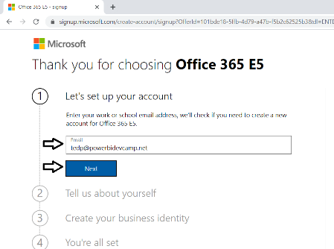

If you enter an email address for an organization account, the form provides the option to sign in. Do not click the **Sign in** button because you don't want to sign with an existing organization account. The purpose of this exercise is to create a new organizational account in a new Microsoft 365 tenant.

* 1. Click the **Create a new account instead** link.

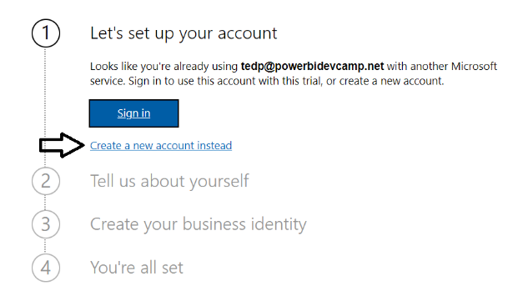

* 1. Enter your **First name** and **Last name**.
  2. Enter your mobile phone number as the **Business phone number**.
  3. Provides values for **Company size** and **Country or region** and click **Next**.

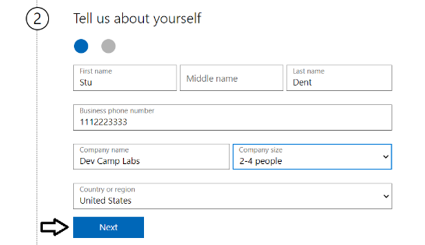

Whatever **Company name** you enter will be used as the name of the Azure AD tenant that will be created during the sign up process.

* 1. When prompted to prove you're not a robot, select the **Text me** option and ensure Phone number of for your mobile phone.
  2. Click **Send Verification Code**.

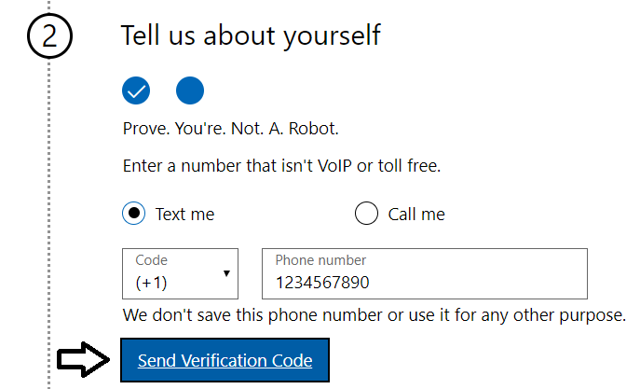

* 1. Retrieve the access code form your mobile device and use it to complete the validation process.

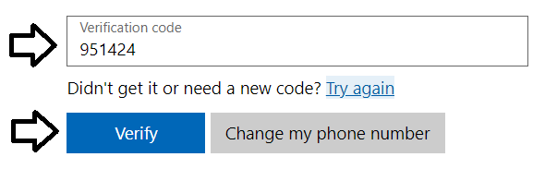

* 1. In the **Create your business identity** step, locate the textbox into which you will enter a domain name.

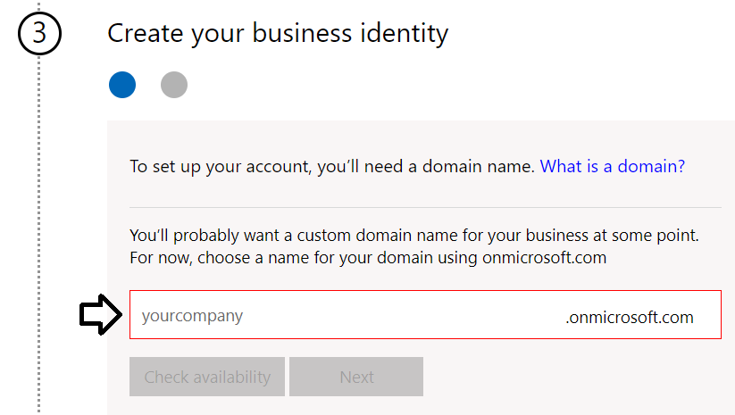

Note that the company name you enter in this textbox will be used to create an Internet domain name for a new Microsoft 365 tenant. For example, if you were to enter a company name of **cptstudent**, it would result in the creation of a new Office 365 tenant within a domain of **cptstudent.onMicrosoft.com**. The user name you enter will be used to create the first user account which will be given global admin permissions throughout the Azure AD tenant. If you enter a user name of **Student**, then the email address as well as user principal name for this account will be **student@cptstudent.onMicrosoft.com**

* 1. Enter a domain name for your new Microsoft 365 tenant.



* 1. If the domain name you enter is not available, modify the domain name until you can verify that it is available.
  2. Once you have created a domain name that is available, click **Next**.

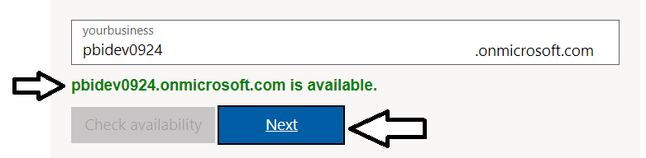

* 1. Enter a **Name** for your user account, a **Password** that you will remember and then click **Sign up**.

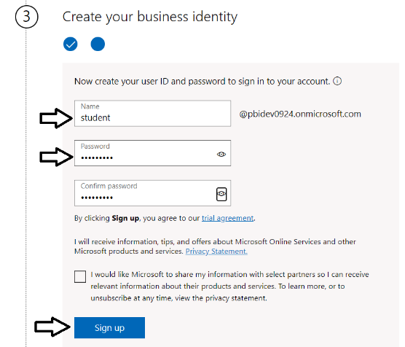

At this point, the Sign up process should begin to provision your new Microsoft 365 tenant and your new organizational account.

* 1. Once the provision process completes, take note of your new **user ID** and click the **Go To Setup** button.

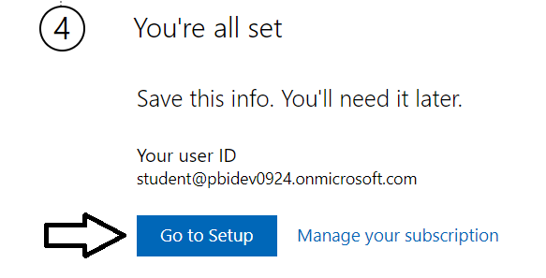

You have just created a new Microsoft 365 tenant with a 30-day trial for 25 Office 365 E5 licenses. Note that some Microsoft cloud services within your new tenant such as the Microsoft 365 admin center, Power BI, PowerApps and Flow can be accessed immediately. Other Office 365 services such as SharePoint Online, OneDrive for Business and your Outlook mailbox will not be ready immediately and can take some time to provision.

* 1. If you see the **Personalize your sign-in and email** setup page, click **Exit and continue later**.

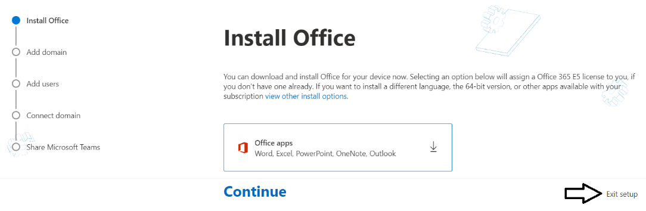

* 1. You should now be located at the home page of the **Microsoft 365 admin center**.

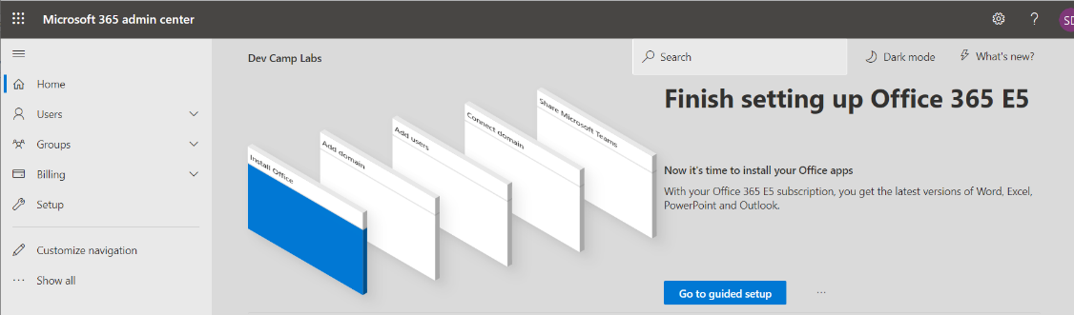

If you don’t see the home page of the **Microsoft 365 admin center**, navigate to <https://admin.microsoft.com/Adminportal>.

1. Inspect the set of active users in the current Azure AD tenant.
   1. Locate the top **Collapse navigation menu** with the hamburger icon just under the Microsoft 365 App Launcher menu.

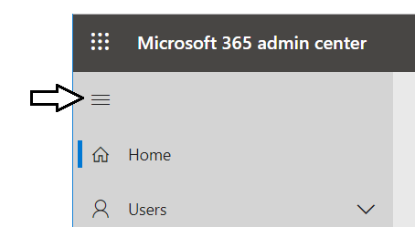

* 1. Toggle the **Collapse navigation menu** button to see how it collapses and expands the left navigation menu.

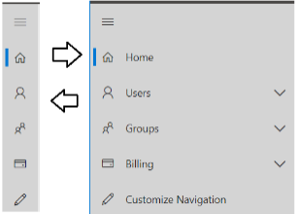

* 1. Navigate to the **Active users** view where you should be able to verify that the user account you are currently logged in as is the only user account that exists in the current tenant.

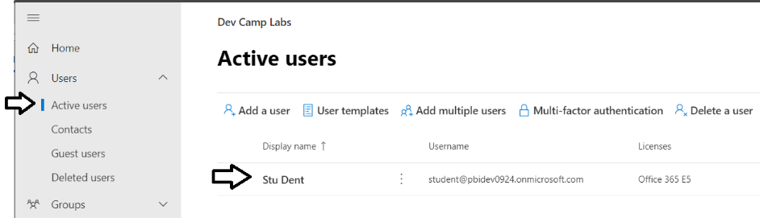

Remember that your account is global tenant administrator. You have permissions to configure any settings throughout the tenant.

1. Create a second Azure AD user account in your new Azure AD tenant.
   1. On the **Active Users** page, click the button **Add a user** button to create a new user account

. 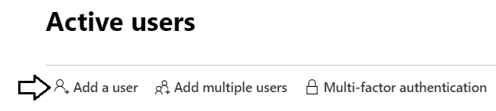

* 1. Fill in the **Set up the basics** form with information for a new user account. When creating this account, you can use any name you would like. These lab instructions will demonstrate this by creating a user account for a person named **James Bond** with a user name and email of **JamesB@cptstudent.onmicrosoft.com**.

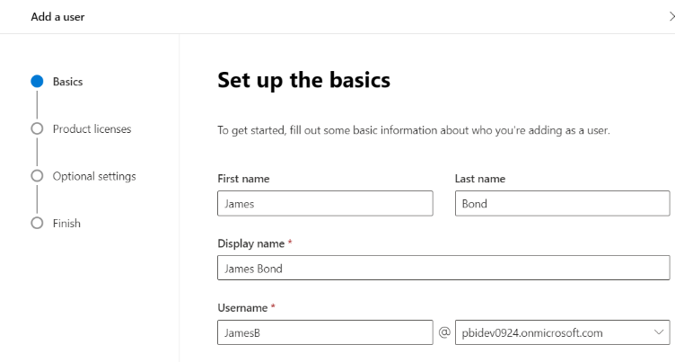

* 1. Move below to the **Password settings** section.
  2. Select the option for **Let me create the password**.
  3. Enter a password of **pass@word1** into the textbox labeled **Password**.
  4. Uncheck the checkbox for the **Require this user change their password when they first sign in** option.
  5. Click **Next**.

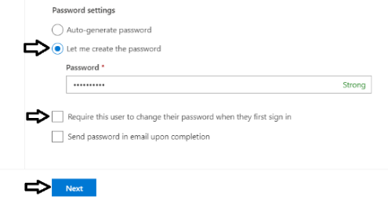

* 1. In the **Product licenses** section, make sure the **Office 365 E5** license is set to **On**.

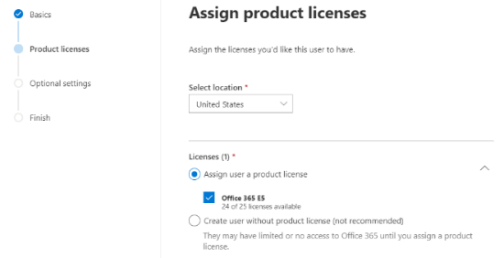

Note that the new account is usually assigned a trial license for **Office 365 E5** plan. However, it’s a good practice to check and make sure the new user has been assigned a license for **Office 365 E5** which includes the **Power BI Pro** license.

* 1. Click the **Next** button down below.
  2. On the **Optional settings** view, click **Next**.

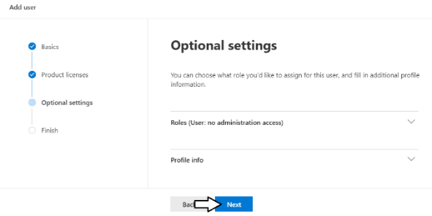

* 1. On the **Finish** view, Click the **Finish adding** button at the bottom to create the new user account.

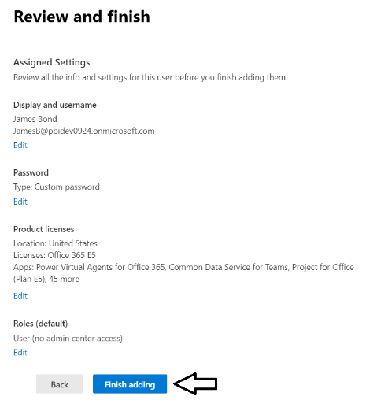

* 1. You should see the **Finish** view with a message indicating that the new user account has been created.

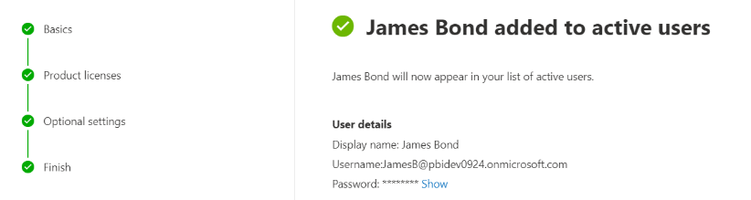

* 1. Click the **Close** button at the bottom of the **Finish** view to close the **Add User** pane on the right.
  2. Verify that the new user account has been created and is displayed along with your primary Office 365 user account.

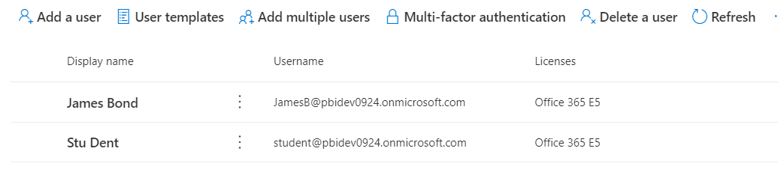

Now you have a secondary user account that does not have any administrative permissions. It's important that you test applications which use first-party embedding with standard user accounts to ensure your application doesn't require users with special permissions.

1. Log into the Power BI Service with your new organizational account.
   1. Navigate the Power BI portal at <https://app.powerbi.com> and if prompted, log in using your new organizational account.

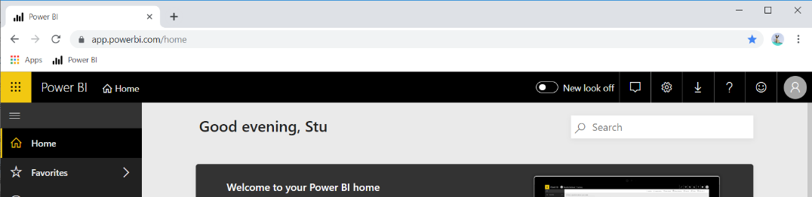

* 1. Locate the **New look** toggle and switch it from **New look off** to **New look on**.



* 1. Click the **Dismiss** button to remove the **Welcome to your Power BI home** panel.

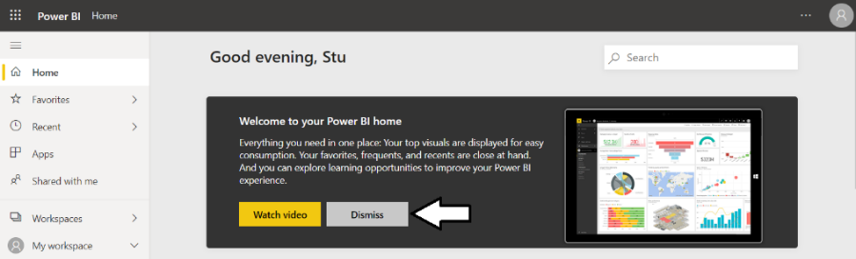

* 1. The home page of the Power BI Service should now match the following screenshot.

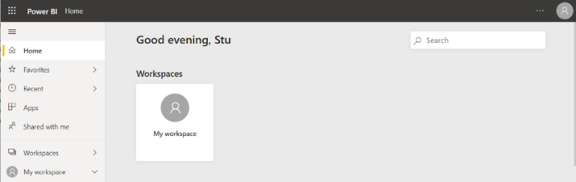

If you haven't worked with the new look of the Power BI Service yet, here's your big chance to get familiar with it.

1. Create a new app workspace named **Wingtip Sales**.
   1. Click the **Workspace** flyout menu in the left navigation.

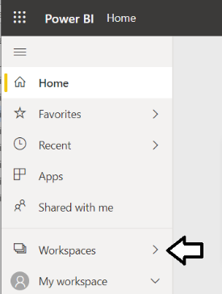

* 1. Click the **Create app workspace** button to display the **Create an app workspace** dialog.

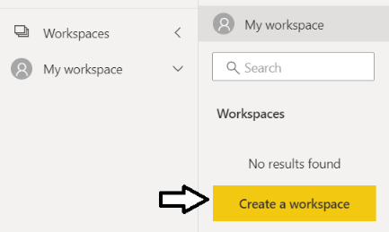

* 1. In the **Create an app workspace** pane, enter a workspace name of **Wingtip Sales**.
  2. Click the **Save** button to create the new app workspace named **Wingtip Sales**.

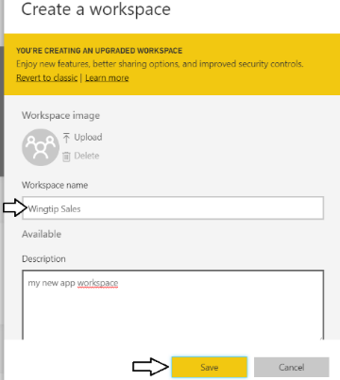

* 1. When you click **Save**, the Power BI service should create the new app workspace and then switch your current Power BI session to be running within the context of this new app workspace.

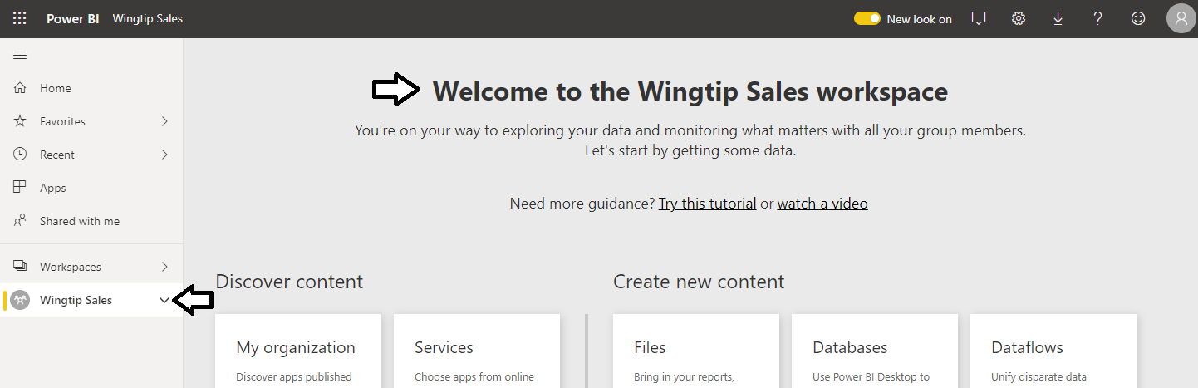

You have now created an app workspace which will provide the foundation for publishing and managing the Power BI datasets, reports and dashboards used by a custom solution.